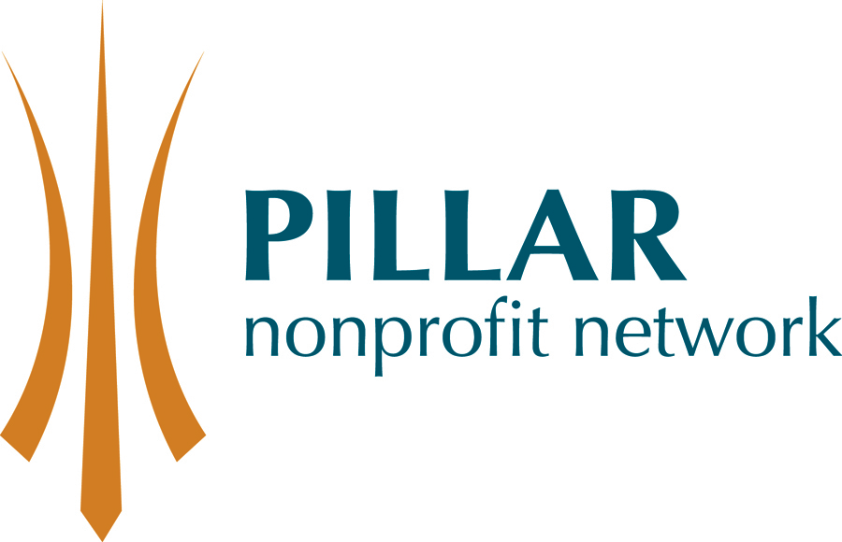
Willy Van Klooster Nonprofit Governance Scholarship
The Willy Van Klooster Nonprofit Governance Scholarship was developed to honour Willy's exemplary leadership in board governance as the founding and long-serving chair of Pillar Nonprofit Network.

It is awarded annually, at no cost to the recipient, to build excellence in board governance for a small-to-medium-sized member organization of Pillar Nonprofit Network. The scholarship provides both theoretical and practical components and includes one-to-one support by a Pillar Board Chair or Past Chair.
This year's scholarship is aimed at organizations that wish to enhance the governance capacity of their board of directors. In particular, this scholarship is valuable to organizations with a new incoming Board Chair and/or Executive Director.

The estimated value of the scholarship is $5000. This program will be approximately 15 hours in total over 9 months.

Eligibility Criteria
- Organization must be a member of Pillar Nonprofit Network
- Operating budget must be under $500,000

The Process:
- Applications must be received by 5 PM on May 29, 2015.
- Send applications to:
Pillar Nonprofit Network, 251 Dundas Street, London, ON N6A 6H9
Fax: 519-435-0227
Email: membership@pillarnonprofit.ca
- Note: If sent by email, please scan the form to include the signatures
- Selection committee will review applications and identification of the recipient will be announced in early June
- The scholarship activities must be completed by March 31, 2016

To Apply:
Interested applicants should submit the attached application form. The form should be submitted jointly by the Board Chair and Executive Director (or CEO, etc.) and signed by both.
Willy Van Klooster Nonprofit Governance Scholarship
Application Form

Part 1 About Your Organization

Organization Name |  | Phone |  | Website
Address |  | City, Postal code |  | Year of incorporation
Executive Director |  | Email address |  | Phone no.
Board Chair |  | Email address |  | Phone no.

Mission/Vision:

Who do you serve?

How do you serve them?

How many do you serve?

Describe the impact of your organization on the community you serve.

Part II About Your Governance/Leadership

Executive Director:
- Year started with organization: | - Year started as ED:
- Number of staff in organization: | - What is your current annual operating budget?
Board Chair:
- Length of time on Board: | - Time in role as Chair:
- What do you want to accomplish as the Chair?
- Describe Board / ED relationship:
Board of Directors
- Length of terms of directors: | - Board meeting frequency:
- Number of directors specified in by-laws: | - Number of current directors:
- Do you do an annual Board evaluation? | - Do you have a Board succession plan?
- Do you have governance policies in place?
- Do you have a current strategic plan? | - If so, when was it written?
  - Describe the Board’s involvement in the planning process:
  - Does the plan include goals or objectives for improved governance?
- Best success as a Board?
- Board’s greatest challenge?
- What have you done in the past to improve the governance of the organization and what were the results?
- Why is this scholarship important to your Board and organization?
- How do you believe it will strengthen the effectiveness of your Board?

Board Chair |  | Executive Director |  | Date

